CSE 581

**Project 3**

Nidhi Surya Prakash

SUID:215895619

Create 4 *Stored Procedures* which can be executed by database role “Graders” (GRANT EXECUTE ON SCHEMA::[yourSchema] TO Graders;) :

* SP to use cursor(s)
* SP to update data in a table (perform validation)
* SP to delete data from a table
* (5% bonus point) 1 SP of your own choice, performing a business action[1].

Create 1 *Function* which can be executed by “Graders”. Not the function you did for the lab.

You will also *create a view* (named as “Benefits”) which can be viewed by “Graders” (GRANT SELECT ON SCHEMA::[yourSchema] TO Graders;) that shows every employee’s name, ID, benefit’s type, benefit coverage, employee premium and employer premium.

Your deliverables will be:

* scripts used to create all of the DB objects described above; each object needs a **short** explanation as to its purpose or goal (i.e. “This SP does this, that and the other thing..”)
* screenshots demonstrating that the SPs work as expected (including valid/invalid inputs). Refer to our SP lab for more details.
* a text file with SELECTS against your views, EXECUTE against your function & stored procedures

**Requirements:**

1. You **shall** create 1 view.
2. You **shall** create 4 stored procedures.
3. You **shall** create 1 function.
4. You **shall** submit all of your SQL code, used to create the DB objects (view, SPs and function).
5. You **shall** submit a short (a single sentence) explanation of what the purpose of each of the DB objects is.
6. You **shall** execute all of the SPs/function (provide screenshots of execution the way you did in the previous labs (SP & function labs)).
7. You **shall** submit a text file that will run SELECTs against of your view and execution of your SPs and function.

**FUNCTION:**

The function created will return the count of a specific gender.

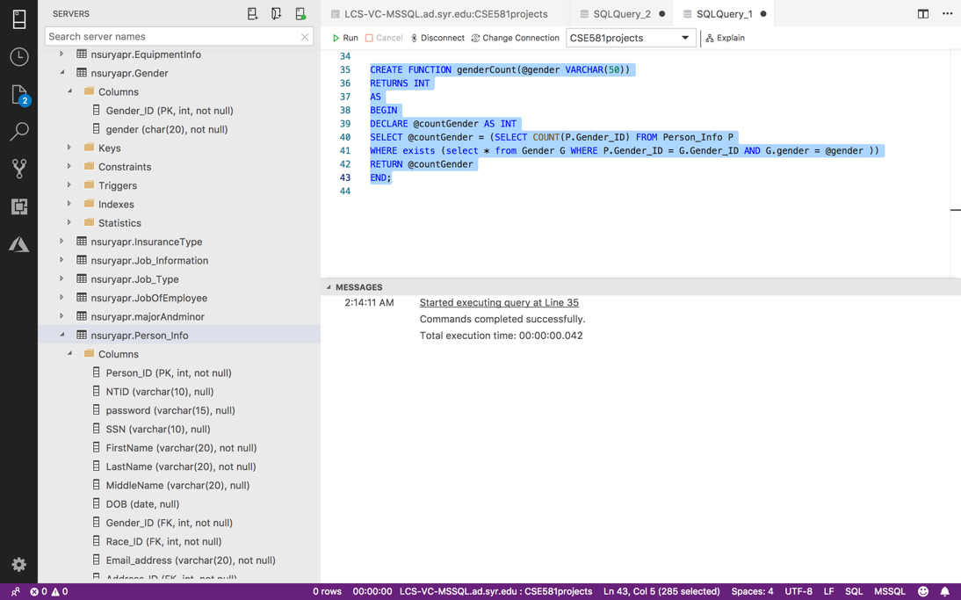

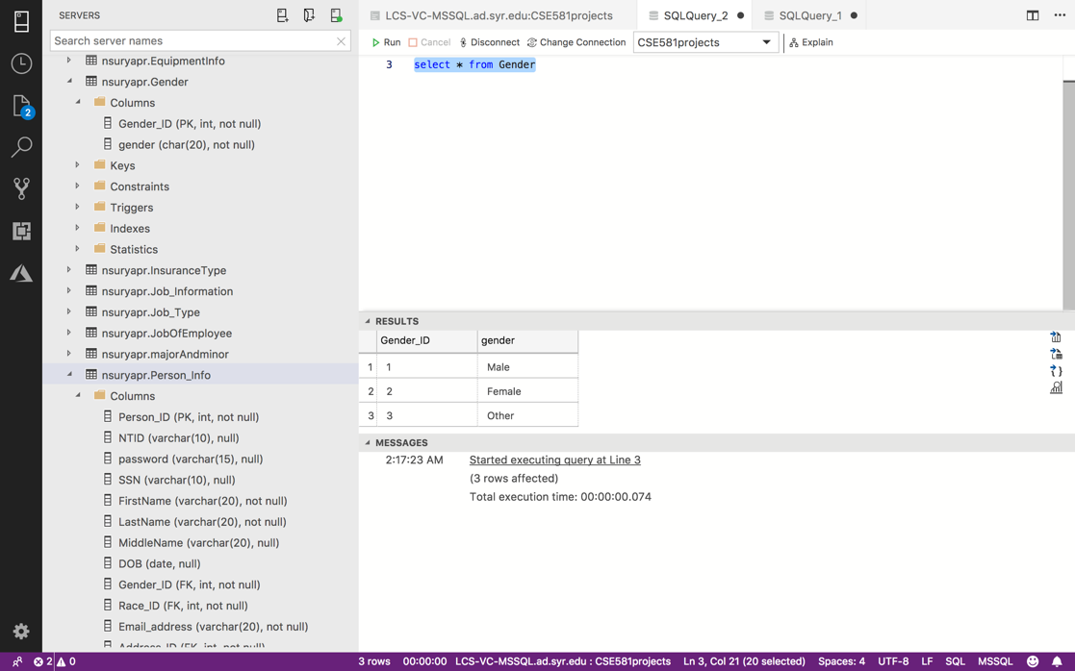

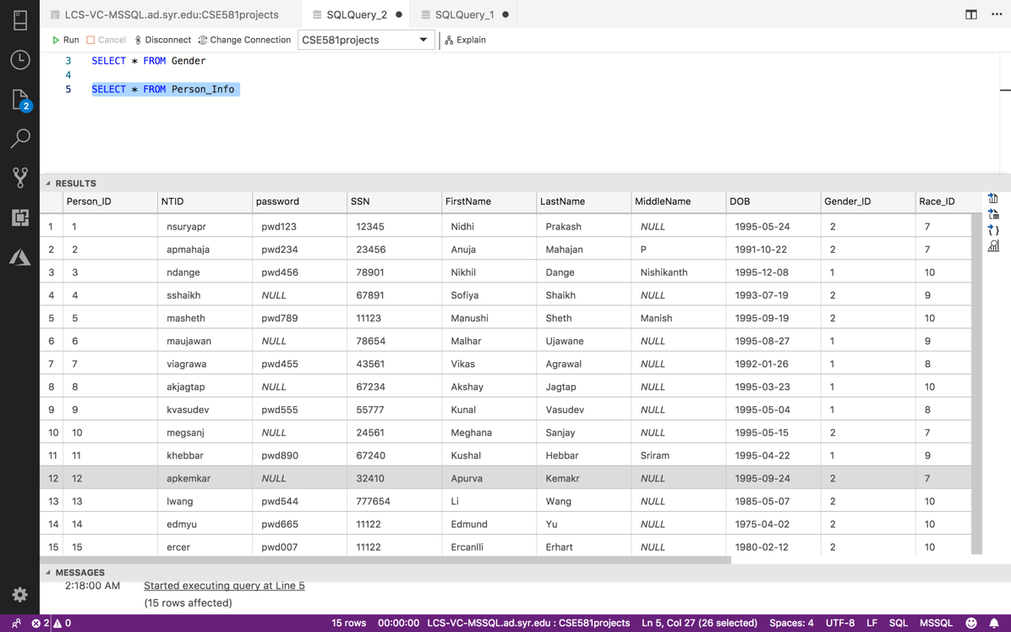

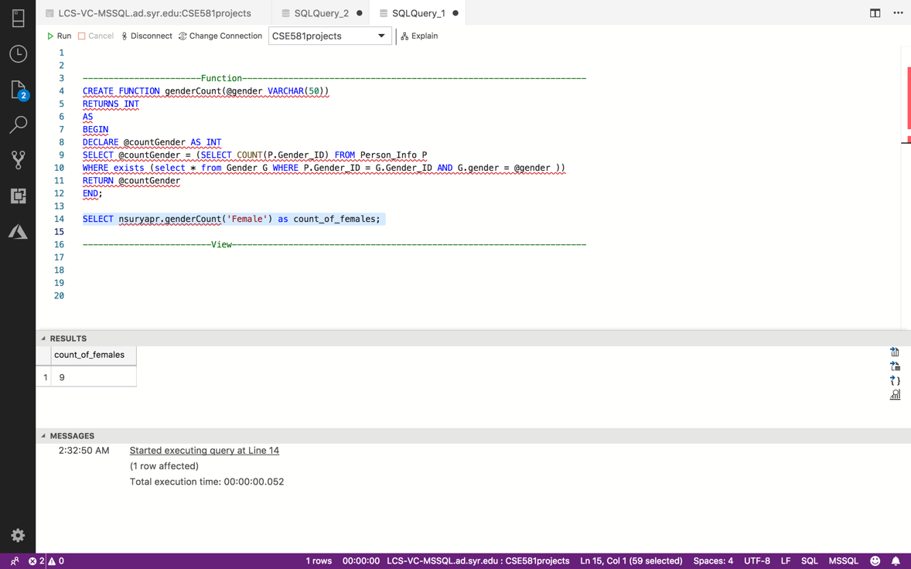

**VIEW:**

Shows every employee’s name, ID, benefit’s type, benefit coverage, employee premium and employer premium.

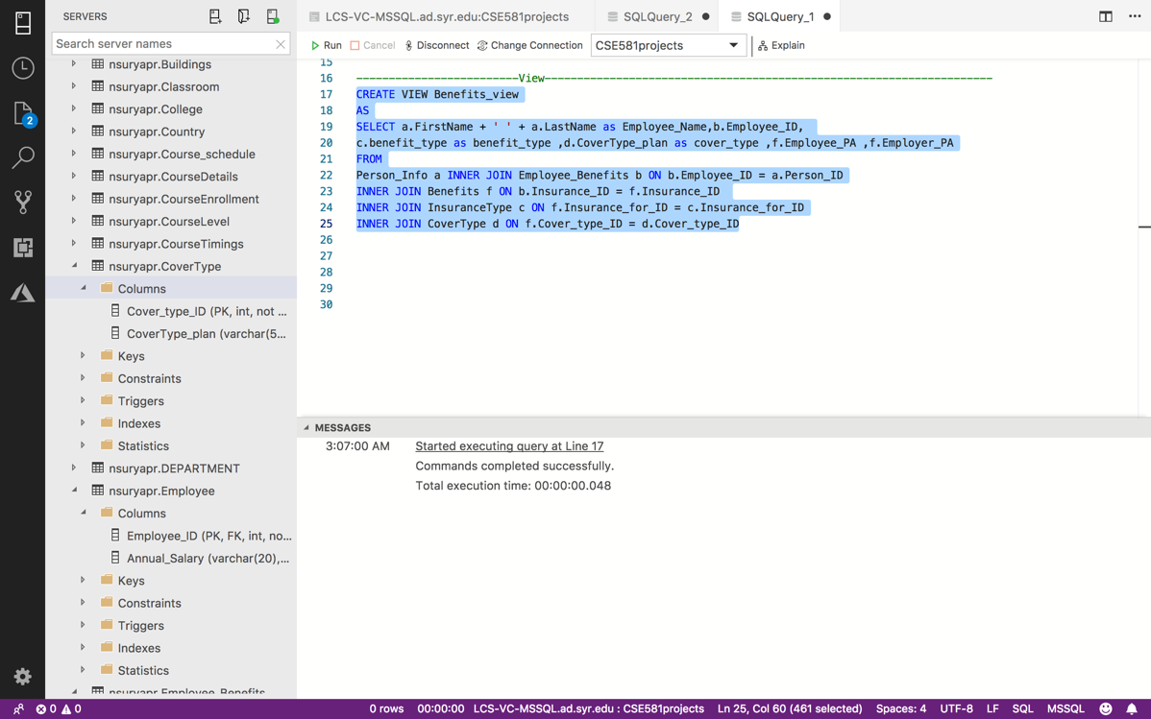

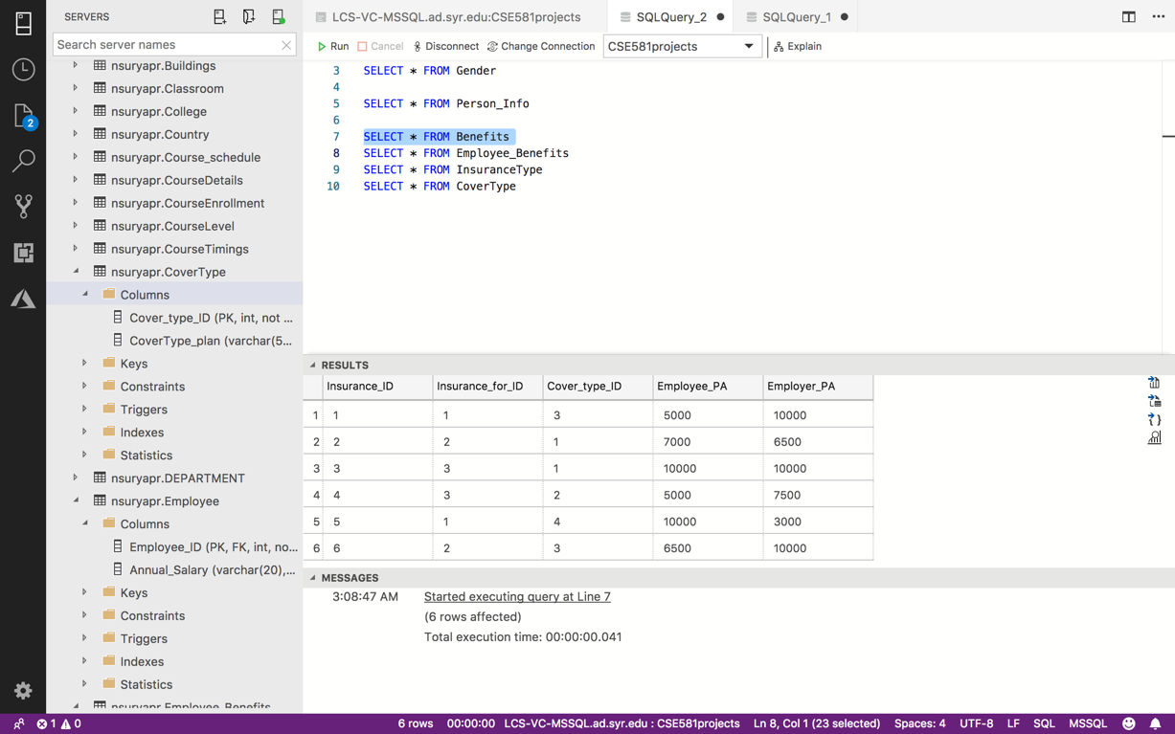

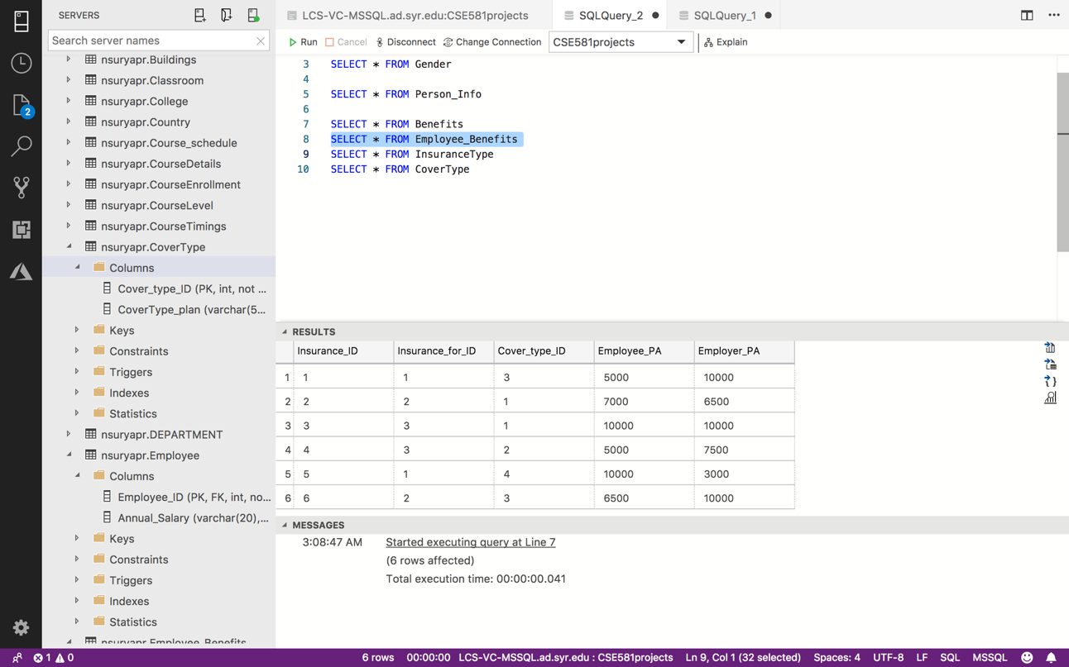

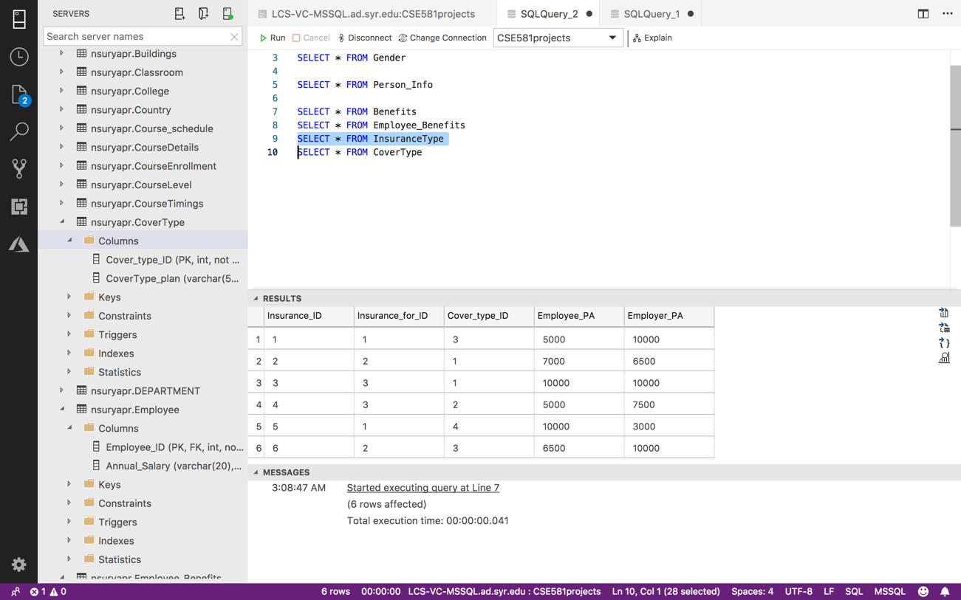

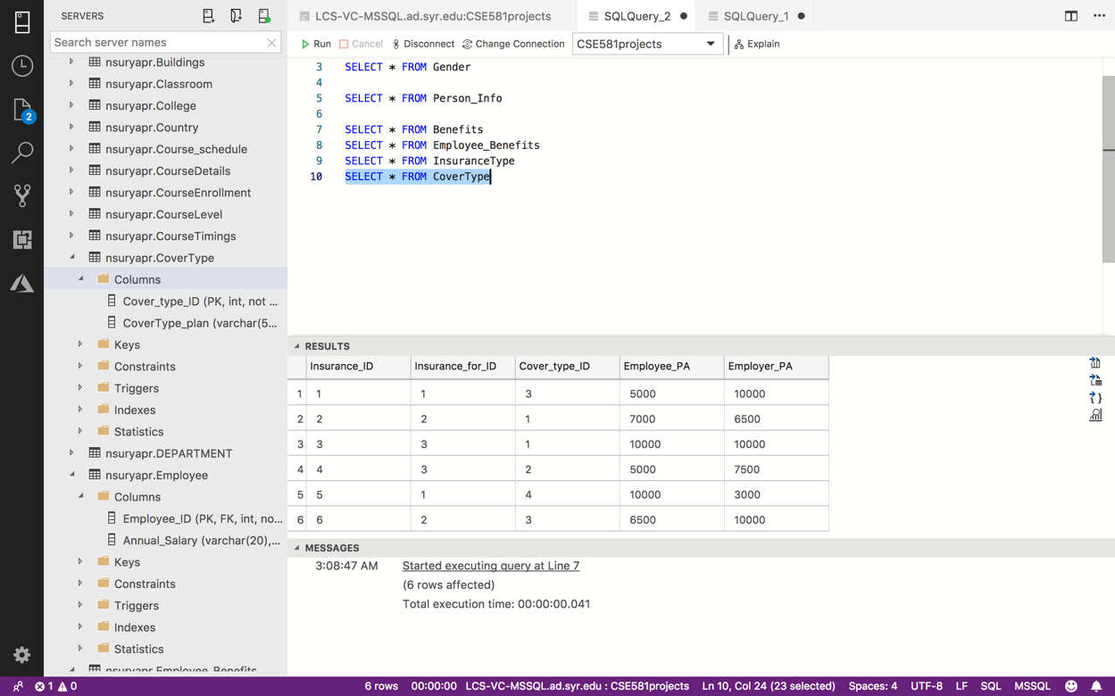

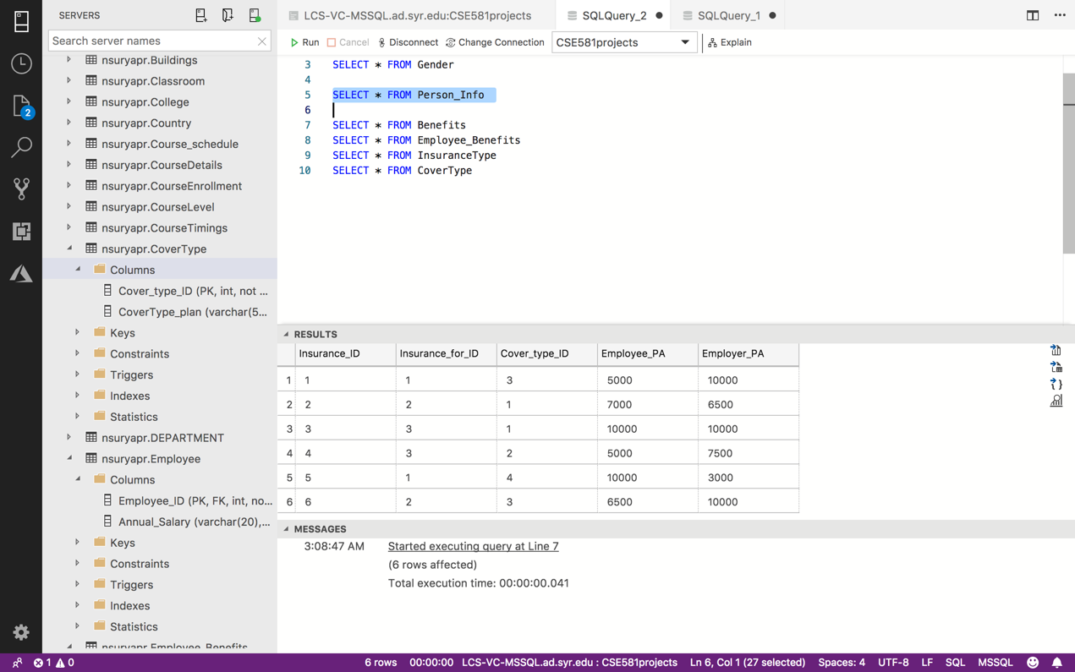

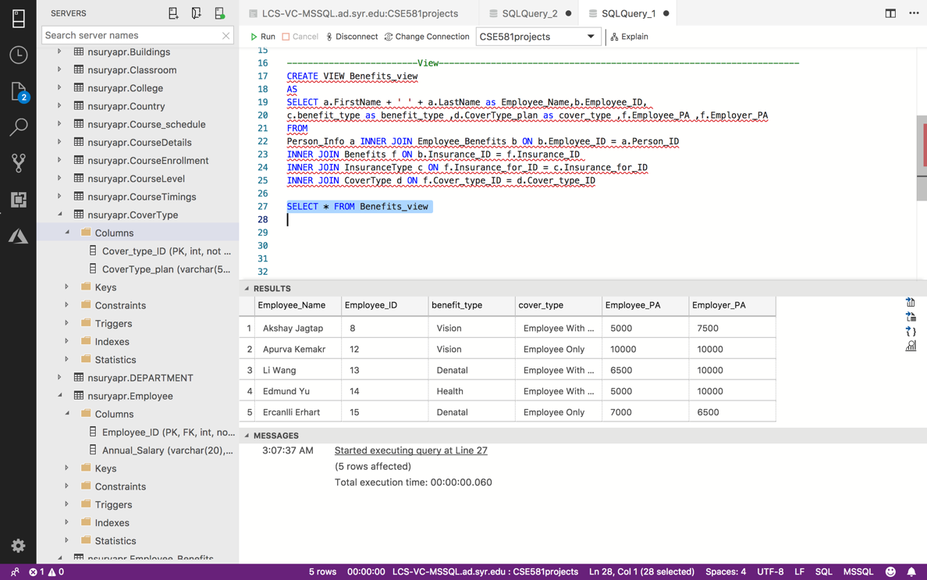

**SP to update data in a table (perform validation):**

The update function takes the person ID, password provided, phone number and email and updates the appropriate table after verifying the following:

* If password is of atleast length 5 else throws an error message
* If phone number entered is valid
* If email entered already exists in the database.

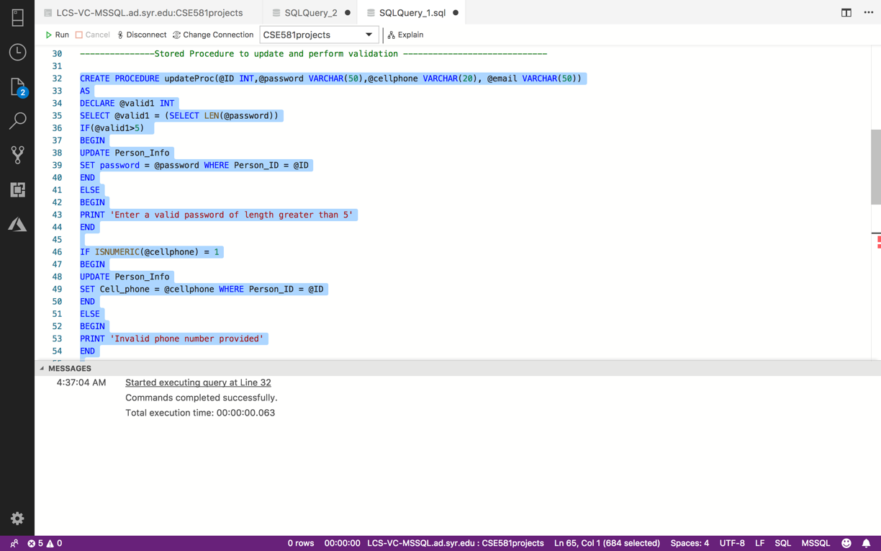

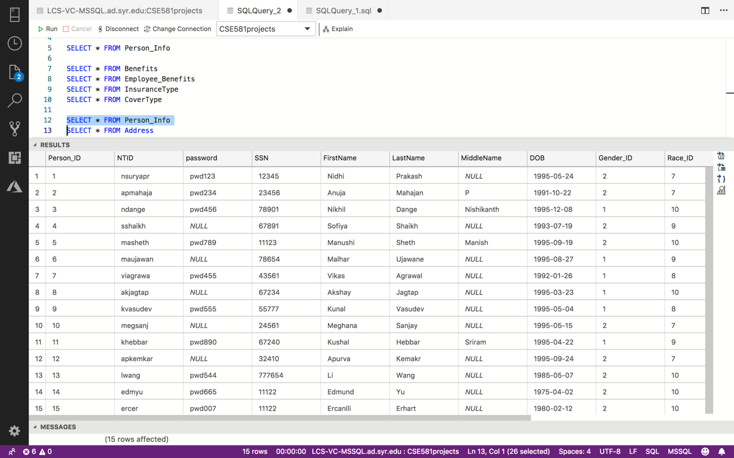

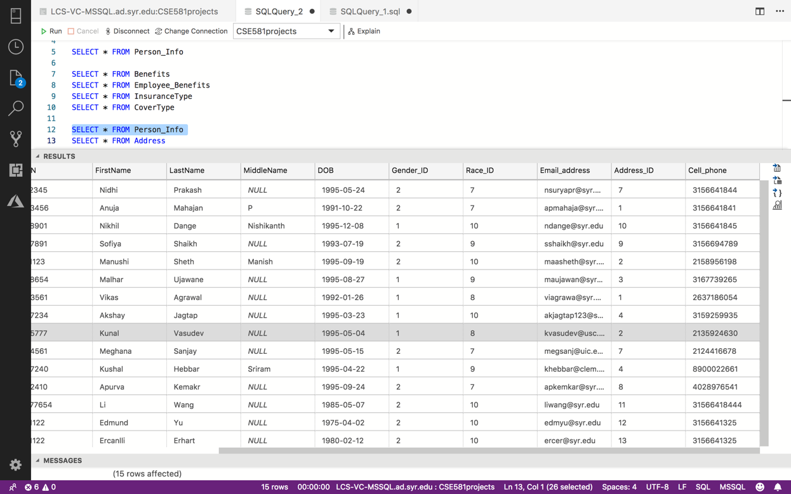

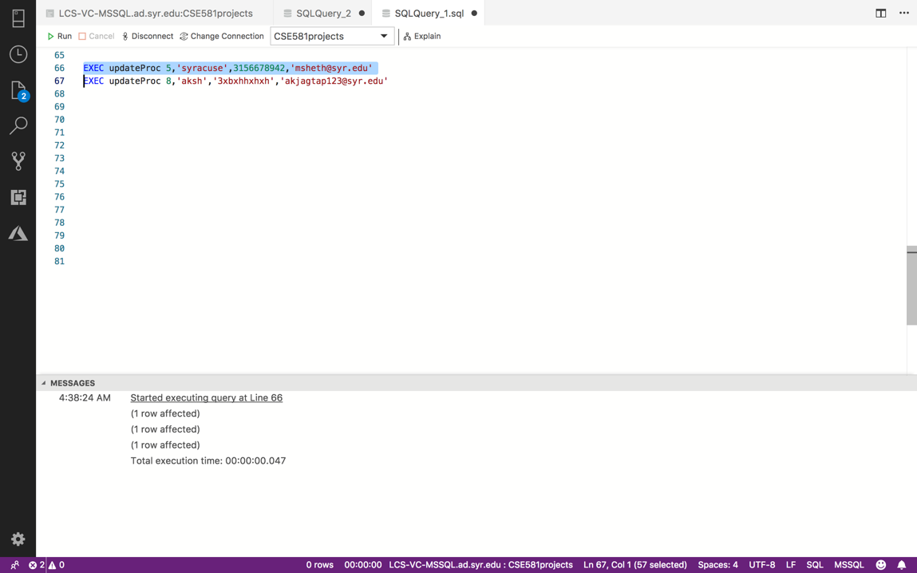

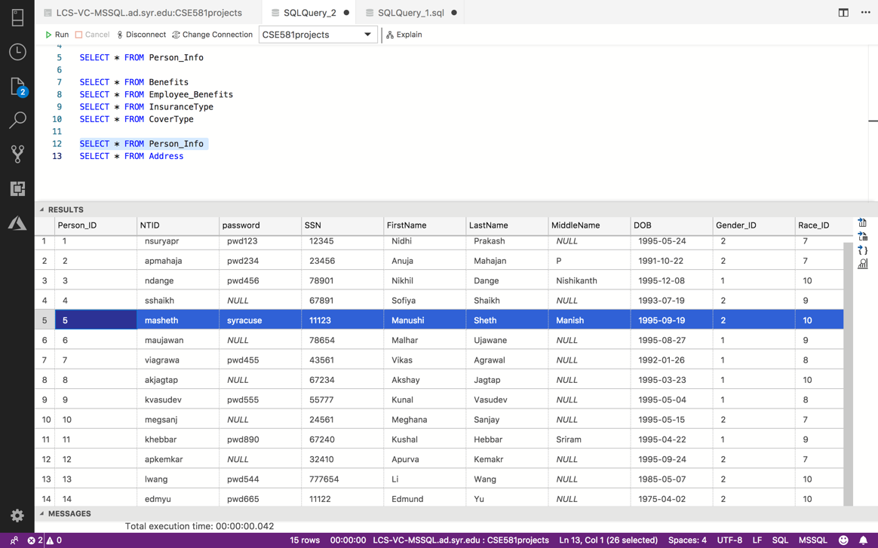

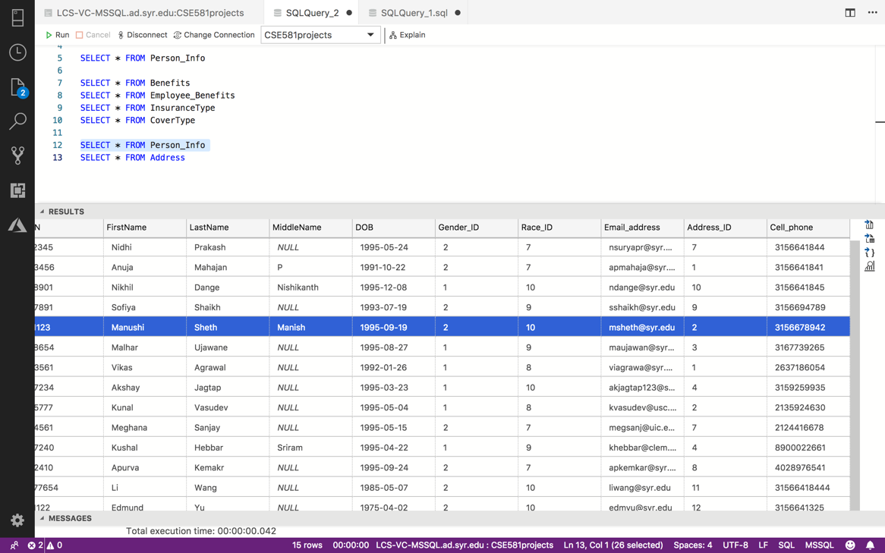

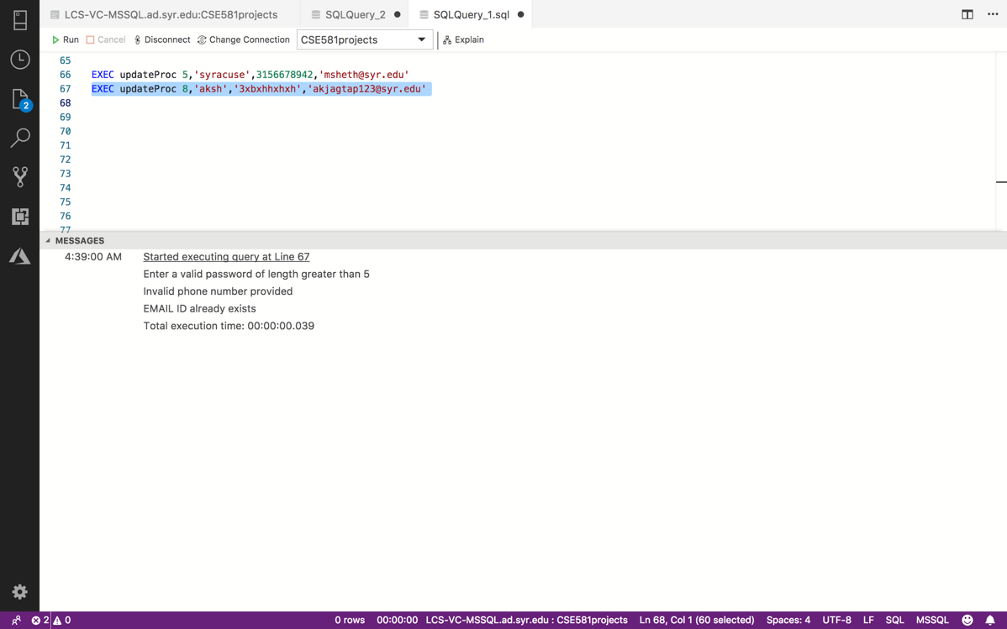

**SP to use cursor(s):**

The cursor stored procedure calculates the average grade of student by taking in the student ID as a parameter.

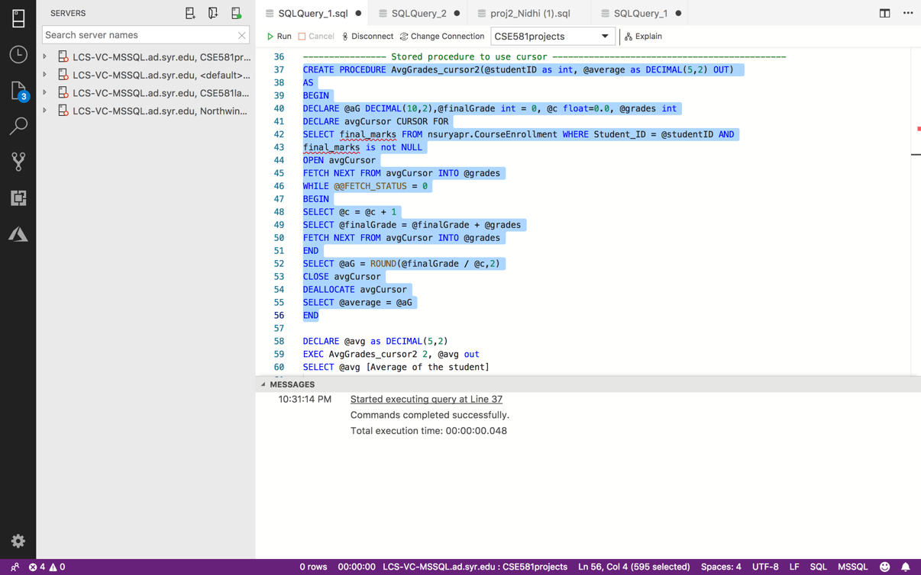

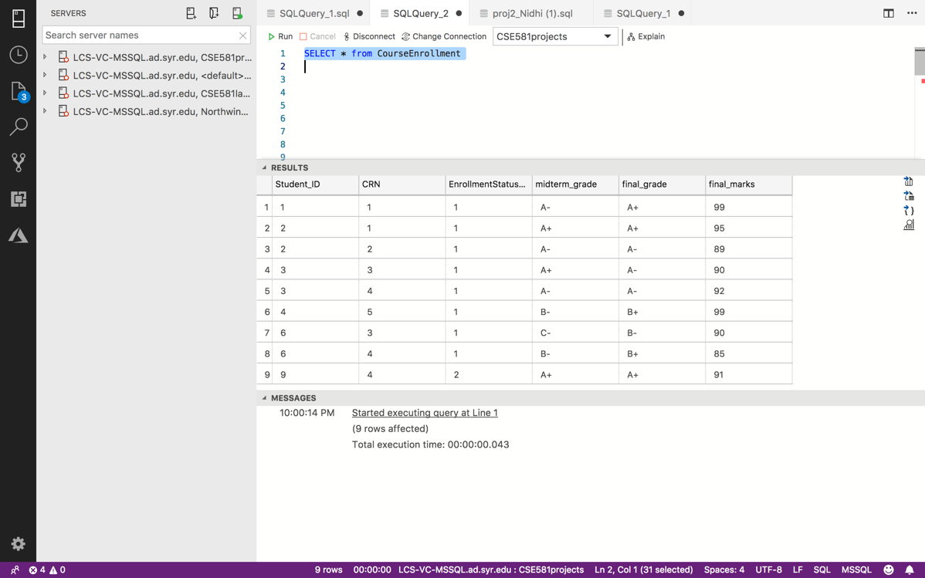

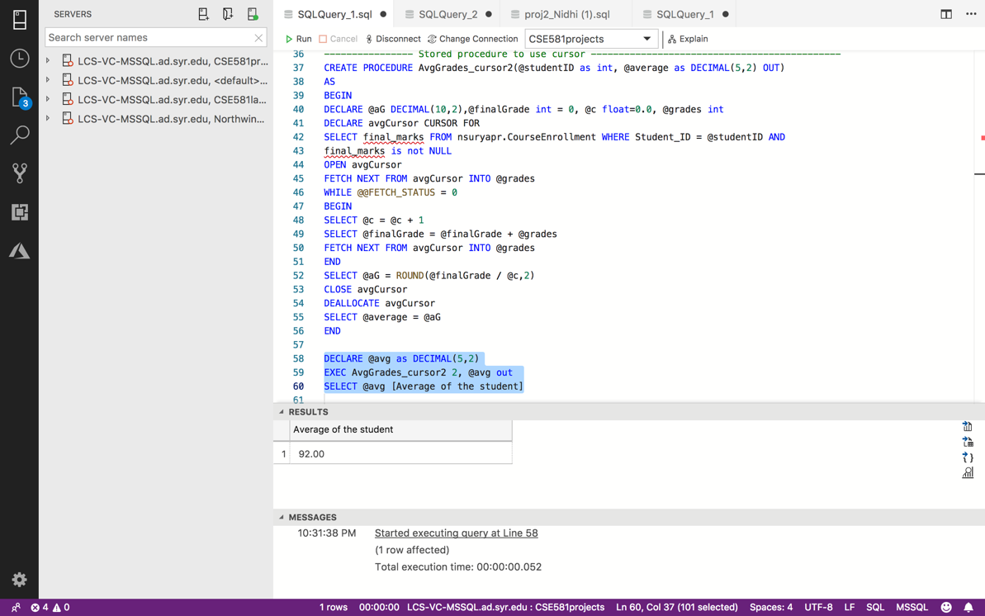

**SP to delete data from a table:**

If an employee decides to leave the university, the employee’s records and all classes handled by him/her will be removed from the database.

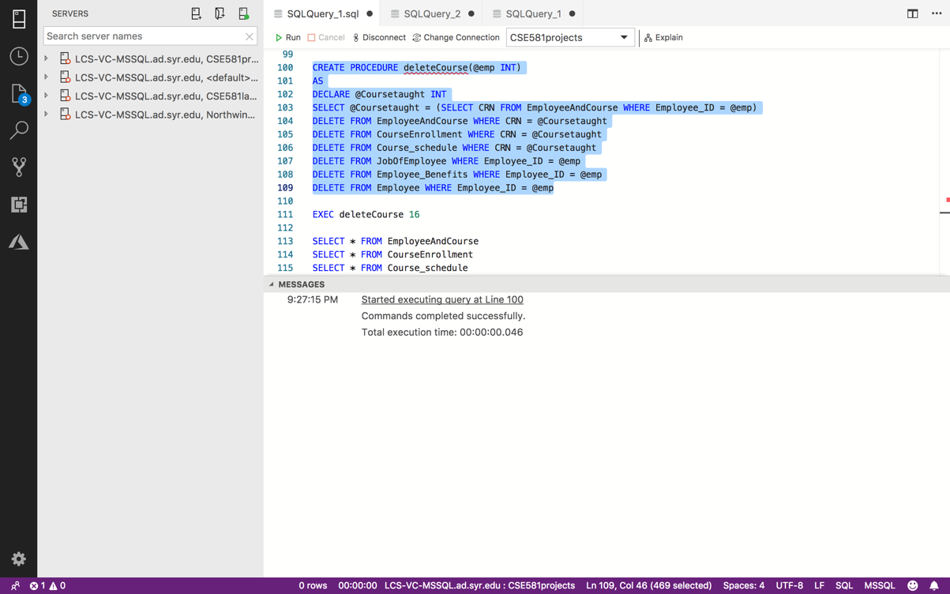

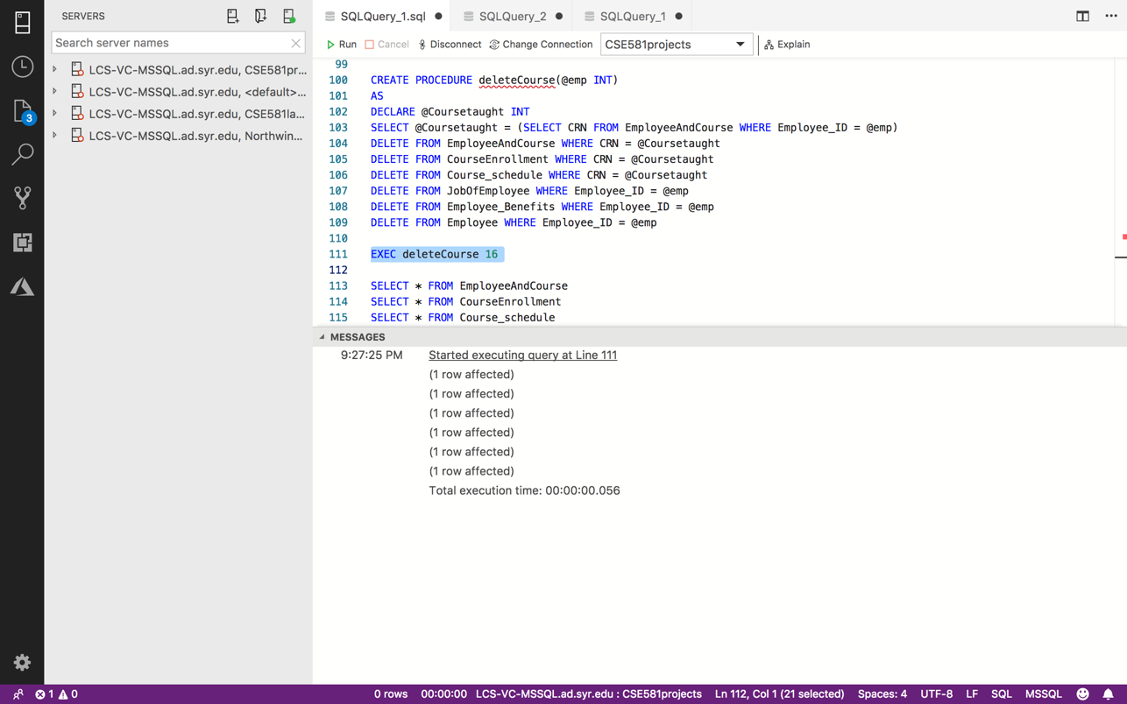

Employee and course table before and after execution of delete stored procedure

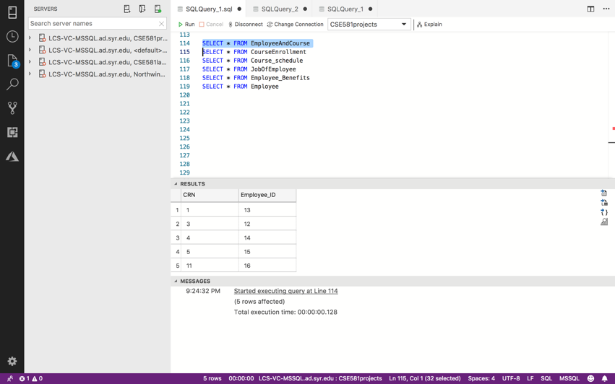

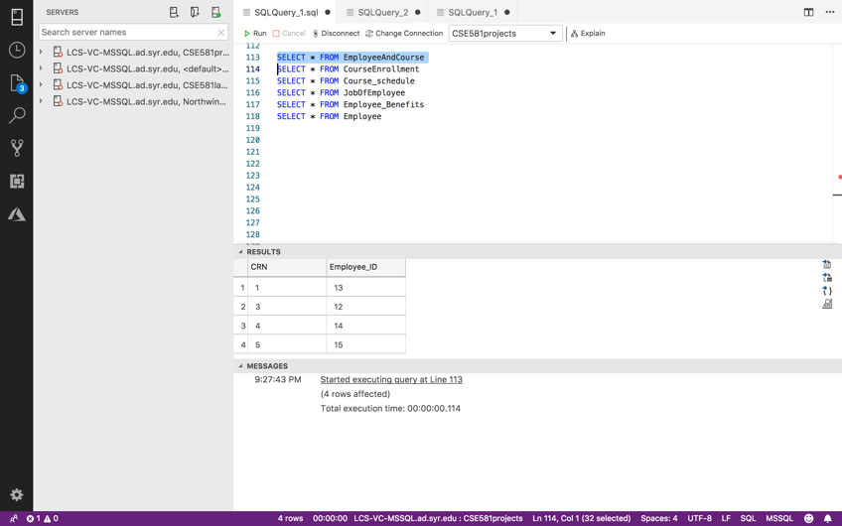

Course enrollment table before and after execution of delete stored procedure

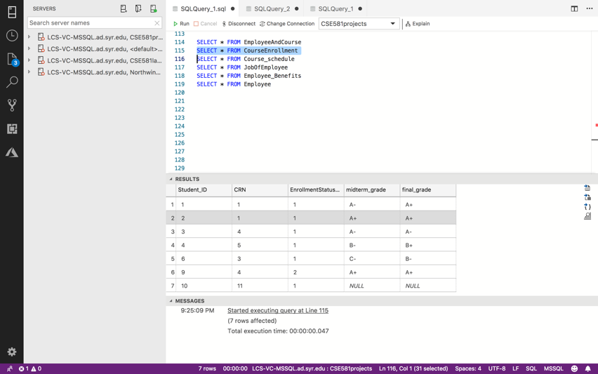

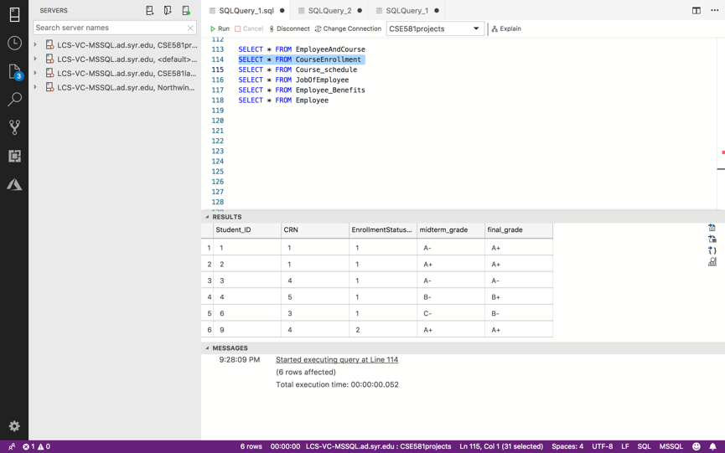

Course schedule table before and after execution of delete stored procedure

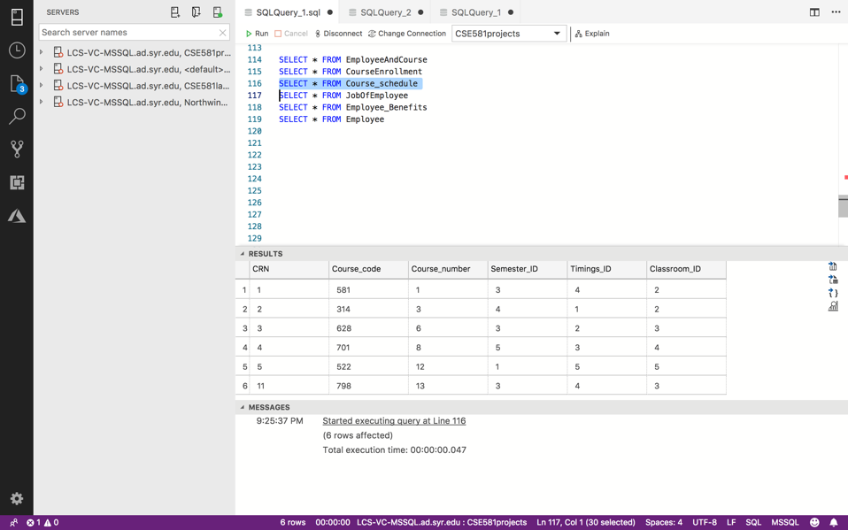

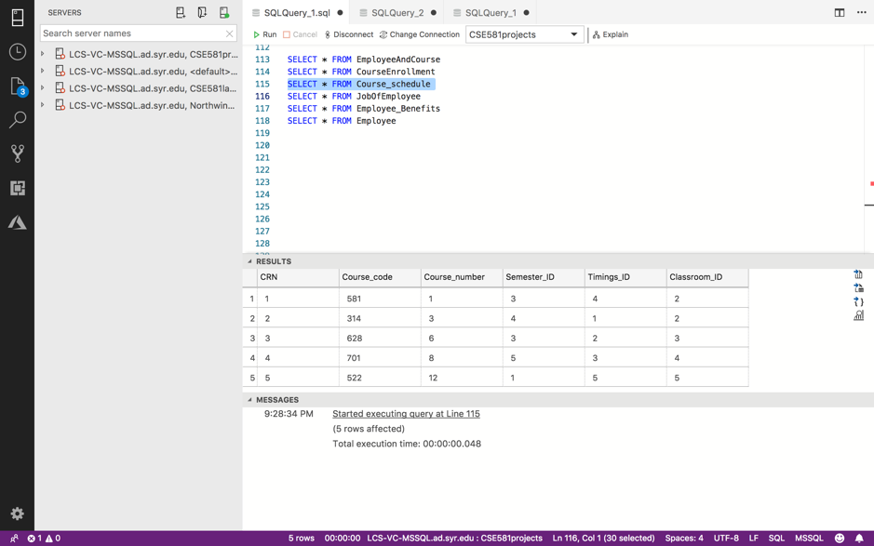

Job of employee table before and after execution of delete stored procedure

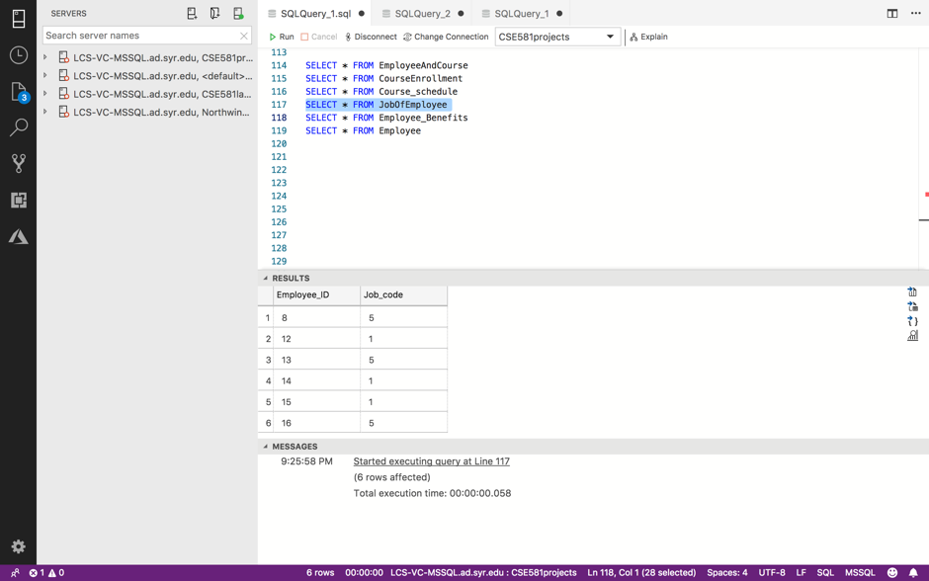

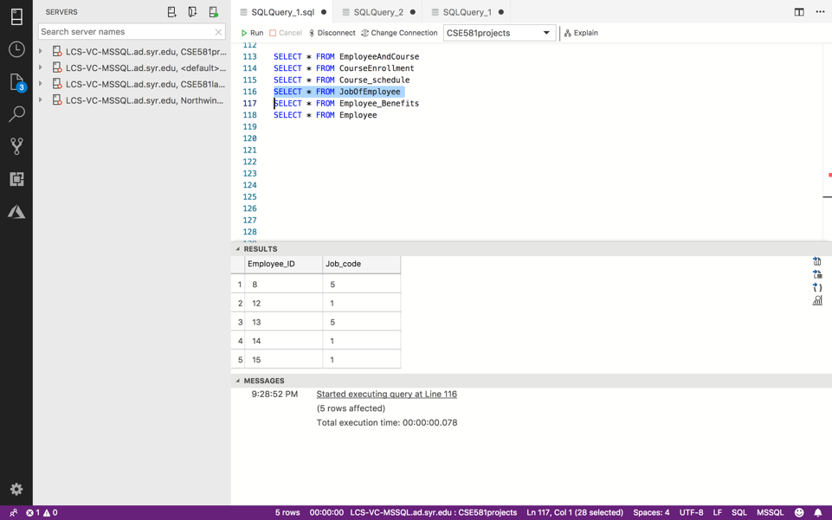

Employee benefits table before and after execution of delete stored procedure

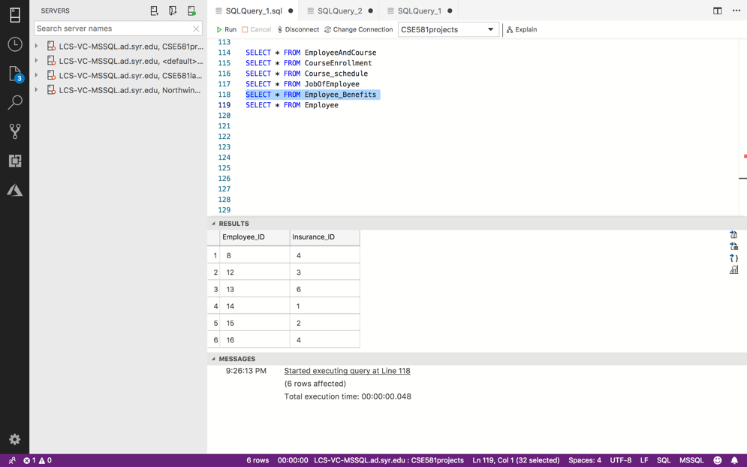

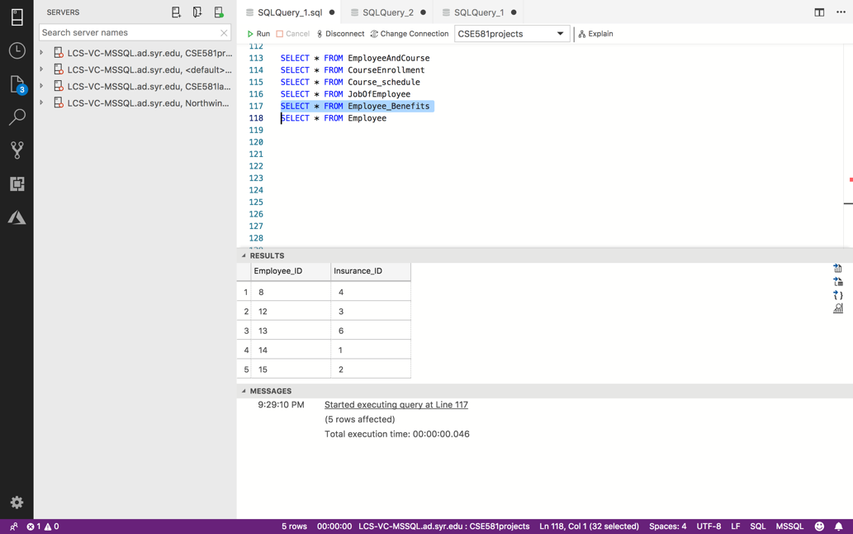

Employee table before and after execution of delete stored procedure

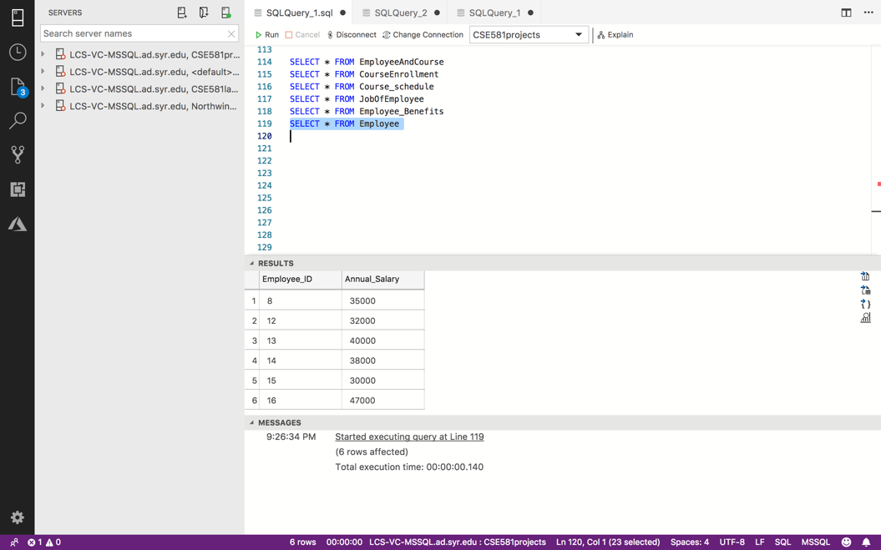

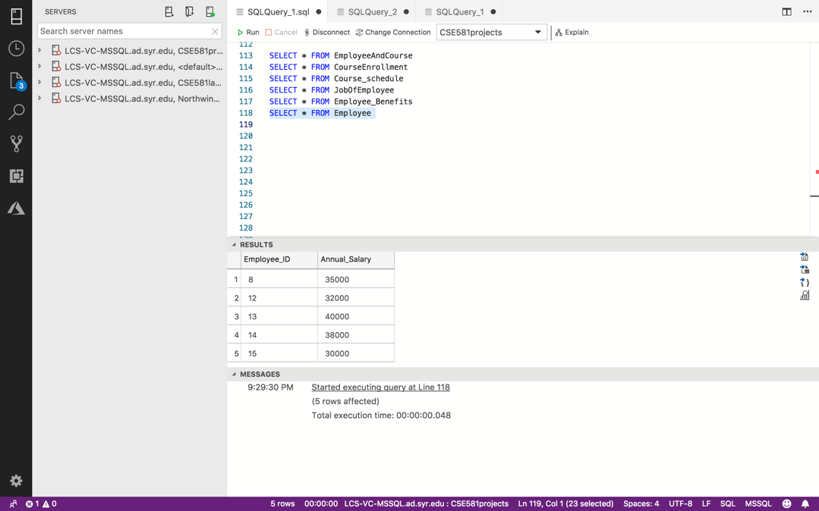

**BONUS QUESTION – STORED PROCEDURE**

If some student/faculty would like to know immediately the details of a class he/she has to attend or know the details of – such as start time and the professor handling the lecture. The stored procedure takes in the class registration number (crn) and gives the details.

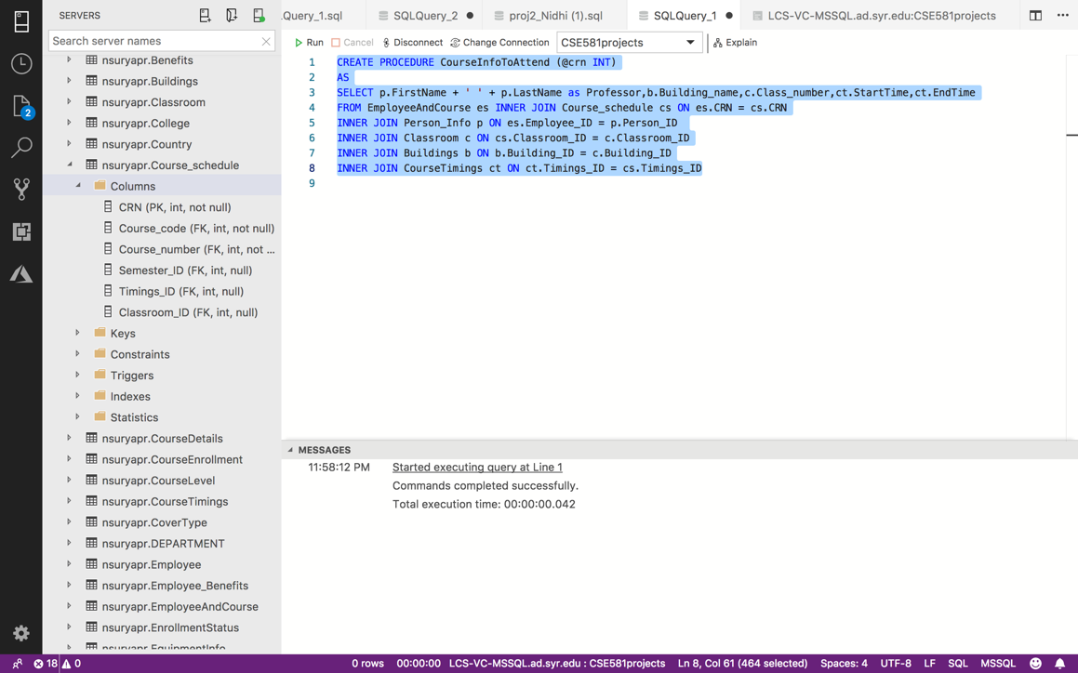

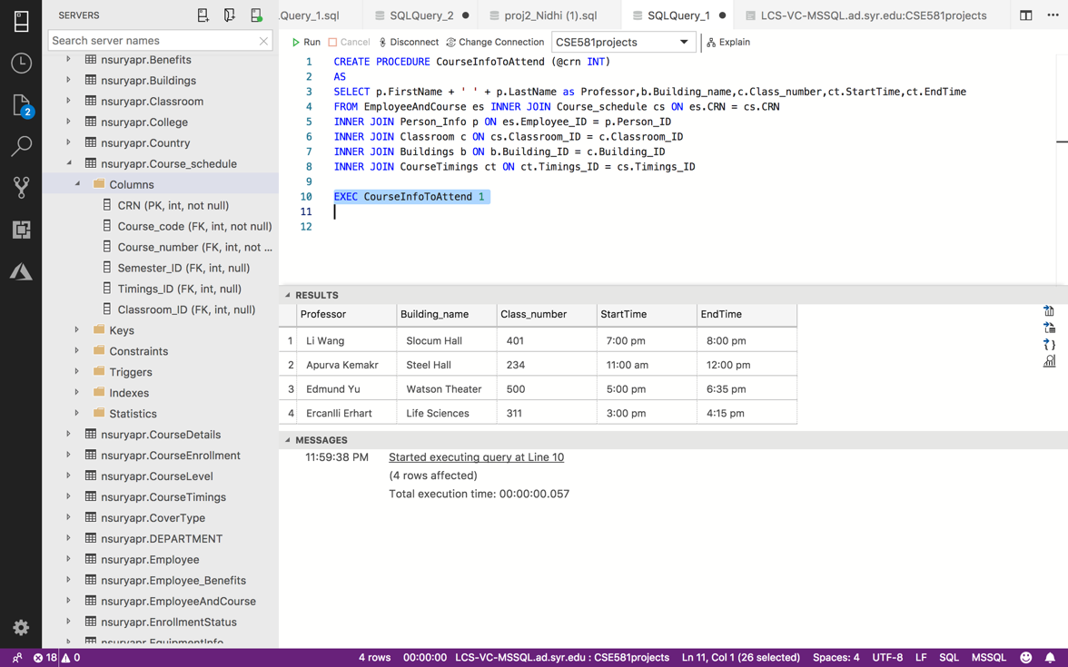

1. You will get 5% bonus if this is a valid action within the scope of the business problem, and the SP is reasonably complex. In other words, a 4 line single-table select SP will get you nothing.